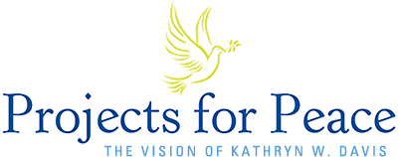 Davis Projects for Peace 2022
“Grassroots projects for the summer of 2022 - anywhere in the world - which promote peace and address the root causes of conflict among parties”
Criteria
- Undergraduate student(s)
- One project from Wartburg College is eligible to receive a $10,000 award
- Creative, engaging, meaningful, measurable
Main Requirements
- Clarity and Feasibility
- Impact and Sustainability
- Cultural Competencies
- Budget (stewardship and commitment)
- Engage the Wartburg community

Important Dates
- Wednesday, January 12, 2022 at 12:00 pm (noon)
  - Proposal due to Kristin Teig Torres via the application on Info Center
https://www.wartburg.edu/davis-projects/
- January 13-18, 2022
  - Review committee meets to discuss applications
  - Additional Information requested and sent to committee if needed – January, 18-20 / Must be submitted by noon on January 20.
- January 24, 2022
  - Recommendations made to cabinet members
  - Working with Kassy Grosser, application is prepared for Davis (submitted no later than Feb. 4 – with forward to Davis by February 7, 2022)
  - Recipients of the Davis Awards will be notified in March
  - Projects completed Summer of 2022
Suggestions
- Identify an on-campus advisor – to help think through project
- Review the application criteria on the website: www.davidprojectsforpeace.org
- If you are partnering with organizations – please include documentation of their support
- Visit with Kristin Teig Torres if you have further questions - kristin.teigtorres@wartburg.edu

Good Luck!

